Ms. Dick’s Third Grade Handbook

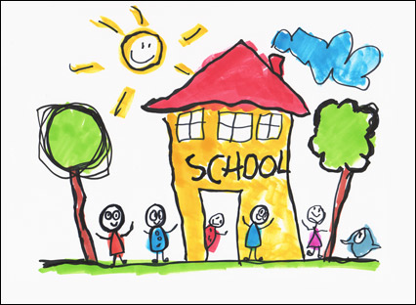

mdick@mssd14.org
http://classroomhappeningsandmore.weebly.com/

Welcome to Third Grade!!!

Dear Parents,

Welcome to Third Grade! It’s going to be a great, fun-filled year. We are going to grow a ton and learn a ton along the way. The purpose of this handbook is to address some questions that you may have about classroom logistics. If you have questions that are not answered in this packet, please feel free to contact me.

Contact Information
Ms. Dick
Email: mdick@mssd14.org
Room: #3

Class Website
Most of what we will be learning and studying will be posted on the class website. In addition, rubrics, important handouts and other sources of information can be found on the website. I will do my very best to keep the website up to date at all times. Be sure to check the websites for new updates and whatnot.
The classroom website will be the best way to see what’s going on in our classroom. Please explore the website and all of the information so that you have an idea of where we are going this year.

http://classroomhappeningsandmore.weebly.com/

Mailboxes
Each student will have a mailbox where I will put papers to go home and graded work. I will encourage students to check their boxes at the end of each day before packing up.

Homework Composition Book
Students will be using a composition notebook for most of their homework assignments. This will help students keep track of their homework and will make grading and checking in quicker and more efficient. Homework assignments will be glued into the notebooks on Mondays and the HW composition book will be turned in for a grade the following Monday. Homework this year should not exceed 30 minutes. However, all students learn differently and may need more time to complete tasks. Please let me know if homework is ever an issue.

Lunch Money
Each morning, lunch money will be collected and taken down to the cafeteria.

Snack Time
We will have snack time each morning with read aloud. I encourage all students to bring one healthy snack to enjoy during Read Aloud. Also, there is not sharing of snacks due to dietary restrictions.

Volunteering
Please let me know if you would like to volunteer in the classroom. I will have a sign up sheet at “Meet Your Teacher Night.” If you don’t sign up then, just send me an email with the times and days that work best for your schedule.

Birthdays
We love celebrating birthdays! If you want to bring in a birthday treat in honor of your child’s birthday, please do. The treat must be store bought and on the healthy side. Please call or email me in advance so that I know when to set aside time for these celebrations.

Behaviors
If necessary, we will use a clip chart in our classroom to monitor behavior. Children who benefit from this structured system will have a clip with their name on it to help them track their behavior. Throughout the day, their clip will move up or down, depending on what types of choices they are making. Here are the clip chart options.

Great Job
Good Choices
Ready to Learn
Think About It
Teacher’s Choice

Students do a lot of growing up in 3rd grade and often these charts become unnecessary. I’m a huge proponent of students taking ownership of their actions. I believe in fair consequences and in student choice. When students make a mistake, I will always offer them a choice in how we proceed to deal with the behavior. This allows students to feel like they are in control of consequences and actions. Behaviors are choices and my goal is to help students make smart choices.

Other Questions?
Once again, if you have questions, feel free to contact me. I check my email constantly.

Thank you!
-Ms. Dick

